Static and Dynamic Collision Avoidance for a Point Mass UAV
or Robot Using Cell DEVS

SYSC-5807
Final project

Rami Youssef
SN# 100204490

Dec 1, 2003

Introduction

Robots or Unmanned Aerial Vehicles encounter some static and dynamic obstacles when they traverse a specific area searching for entities. Therefore, it is necessary for the robot or the UAV to be able to avoid such obstacles and continue its mission.

This project deals with multiple robots or UAVs trying to traverse an area and avoiding both static and dynamic obstacles, which they might encounter as shown in the following diagram.

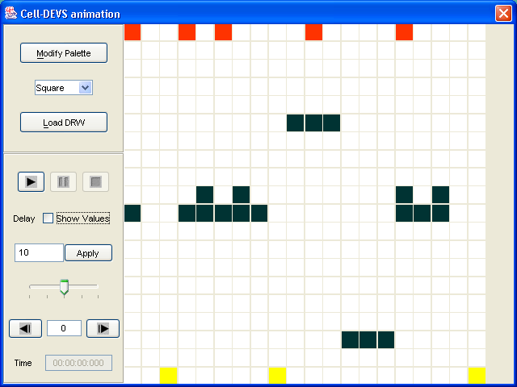

The red squares represent the UAVs or the robots, and the black squares represent various static obstacles, and the yellow squares represent dynamic obstacles that are moving upward. The robot mission is to cross the area top to bottom while avoiding all encountered obstacles, whether static or dynamic ones.

Background

The formal specifications for the cell-DEVS model can be written as follows. Some of them are set to defaults or not used, and not mentioned here.

CD = <X, Y, I, S, Θ, N, d, δint, δext, τ, λ, D>
X = Ø
Y = Ø
S = {0, 1, 5, 9 }
N = neighborhood = { (-2,-2),(-1,-2),(0,-2),(1,-2),(2,-2)
(-2,-1),(-1,-1),(0,-1),(1,-1),(2,-1)
(-2,0),(-1,0),(0,0),(1,0),(2,0)
(-2,1),(-1,1),(0,1),(1,1),(2,1)
(-2,2),(-1,2),(0,2),(1,2),(2,2)
(3,-2),(3,-1),(3,0),(3,1),(3,2) }

D = 100 mS
δint : is defined by the rules of the model
δext : None

The following table shows the specifications of the elements of the model

 | Empty Cells | Robot | D-Obstacle | S-Obstacle
Color
Movement | None |  |  | None
State | 0 | 1 | 5 | 9

The Model is initialized in the MA file, and different scenario setups, can be fixed by proper initialization. The following is an example of one possible scenario:

[top]
components : uav

[uav]
type : cell
width : 20
height : 20
delay : transport
defaultDelayTime : 100
border : nowrapped
neighbors : uav(-2,-2) uav(-1,-2) uav(0,-2) uav(1,-2) uav(2,-2)
neighbors : uav(-2,-1) uav(-1,-1) uav(0,-1) uav(1,-1) uav(2,-1)
neighbors : uav(-2,0) uav(-1,0) uav(0,0) uav(1,0) uav(2,0)
neighbors : uav(-2,1) uav(-1,1) uav(0,1) uav(1,1) uav(2,1)
neighbors : uav(-2,2) uav(-1,2) uav(0,2) uav(1,2) uav(2,2)
neighbors : uav(3,-2) uav(3,-1) uav(3,0) uav(3,1) uav(3,2)
initialvalue : 0
initialrowvalue : 5 00000000099900000000
initialrowvalue : 0 10010100001000010000
initialrowvalue : 15 00000000900000000000
initialrowvalue : 9 00009090000000090900
initialrowvalue : 10 90099999000000099900
initialrowvalue : 17 00000000000099900000
initialrowvalue : 19 00500000500000000005

The starting position of the entities can be changed by reinitializing the model. The model execution conforms to a set of rules that specify how the model behaves under certain conditions. The following example shows a set of possible rules that the robot or the UAV obeys:

[noFlyZone9-rule]
rule : 9 100 { (0,0) = 9 }
%rule : 9 100 { (0,0) = 9 }
.
.
.
[uav-rule]
%000
%???
rule : 1 100 { (0,0)=0 and (0,-1)=0 and (0,1)=0 and (1,-1)!=5 and (1,0)!=5 and (1,1)!=5 and (-1,0)=1}
rule : 0 100 { (1,0)=1 and (0,0)=1 }
.
.

%moving target rule
rule : 5 100 { (1,0) = 5 }
rule : 0 100 { (-1,0) = 5 }
.

expected. Different tests can be conducted, by changing the starting position of the robot and by changing the positions of the static obstacles. That can be done at the initialization part of the MA file. No matter where we started our robot, it was still able to cross to the bottom of the page avoiding all obstacles. However, the case where we have a very large horizontal obstacle wasn’t tested, as it is an unrealistic case to the assumed model.

Attached with a report are some printouts of various execution printouts showing the behavior of the model.

The model was also tested for multiple robots running at the same time, and the results were verified for a specific set of scenarios based on a condition that there is an appropriate
As one can clearly see, there are different rules for each element in the model. For example, the robots have their own rules, the dynamic obstacles have their rules, and the static obstacles have their own rules as well.

The model was tested under different scenarios, starting from one robot traversing an area of static obstacles only, to multiple robots traversing an area of static and dynamic obstacles.
Some of the testing results are attached to this report. The tests generated successful results in most cases, especially when some restrictions were applied, such as a minimum separation distance between the robots. The model can be worked on further and improved even more to account to all possible scenarios.

Conclusion

Cell-DEVS is a very good modeling tool for artificial intelligence. In fact the built model was tested under different scenarios, and in all cases it behaved as expected. However, more work needs to be done to account for all possible scenarios, and then it can be integrated into other models, so one can build a more complete, more rigorous models.

Read me file

In order to run the model
1- At the dos prompt run: runUAV bat file. This will generate a uavoutput.drw file.
2-using the cd++ modeler, open the uavoutput.drw file and use the provided palette file uavpal.pal in order to set the appropriate colors.
3- run the model.

Example 1: One robot in static obstacles only area

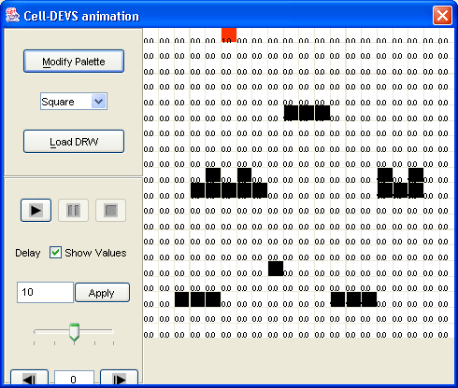

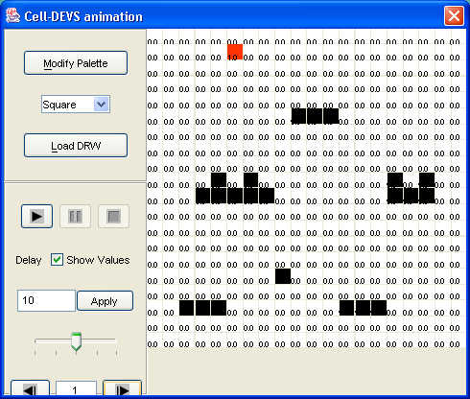
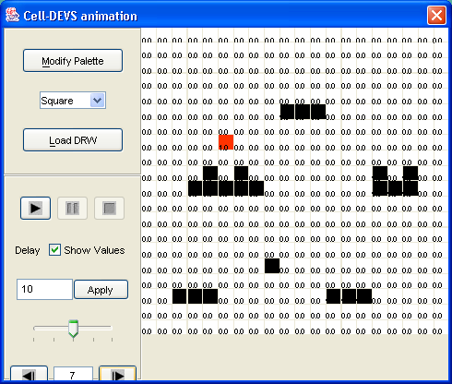

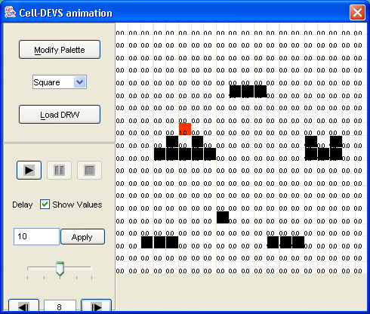

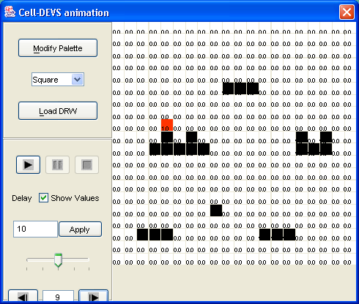

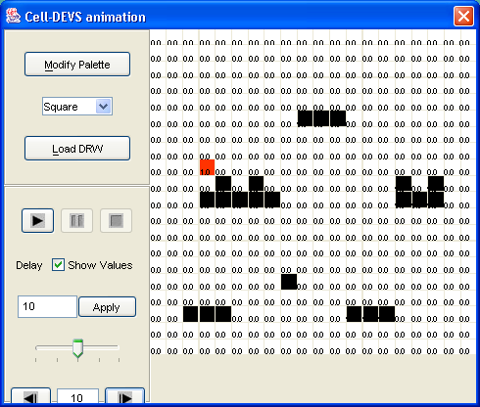
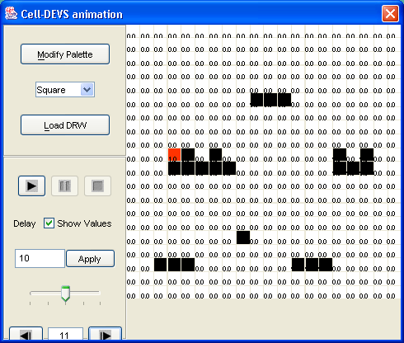

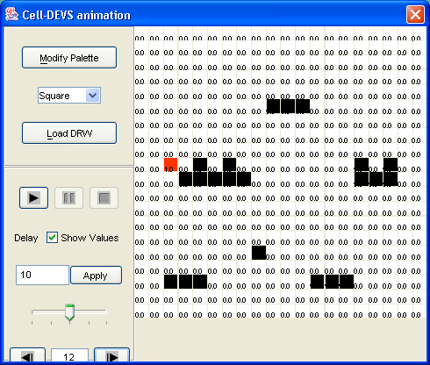
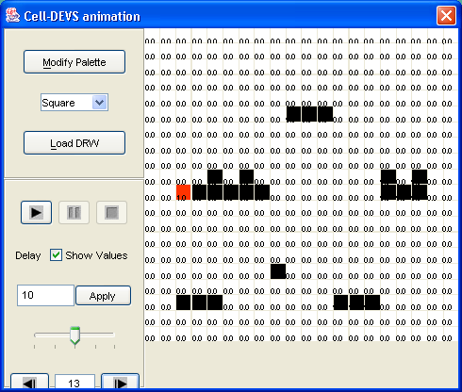

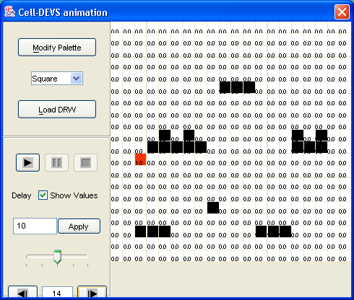
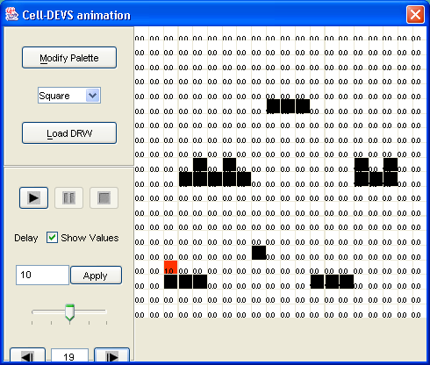

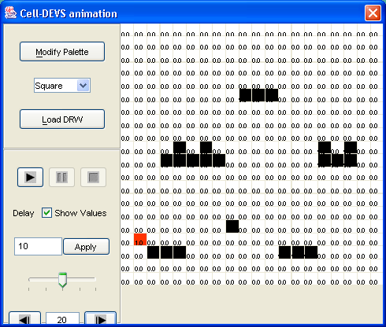
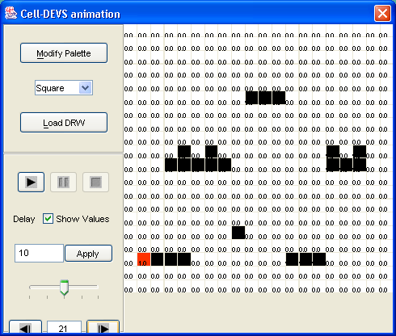

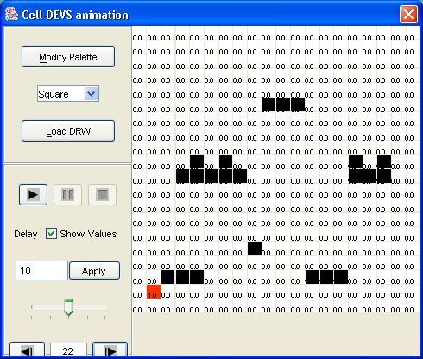
Example 2: Multiple robot in static and dynamic obstacles area

